This IS A Simple Bank System With A Basic Features :

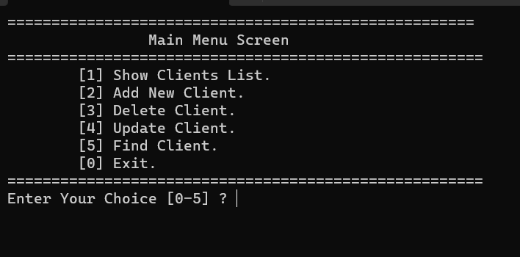

1-Show Clients List From A File (Like Data Base) Inside Project .

2-Add New Client To The File .

3-Delete Client From The File.

4-Update Client From The File.

5-Find Client From The File.

Important Note:

-If You Press 1 And The Program Crashes ->

Delete File Content And Add Clients Again From The Program.